***Assignment – 8 || Arrays Using Function***

Arjun Patel – FRN006

Q)Find max and min element in array

*#include* <stdio.h>

void storeArr(int *\**arr, int size)

{

*for* (int i *=* 0; i *<* size; i*++*)

    {

        printf("Enter value for index %d: ", i);

        scanf("%d", *&*arr[i]);

    }

}

void printArr(int arr[], int size)

{

    printf("[ ");

*for* (int i *=* 0; i *<* size; i*++*)

    {

        printf("%d ,", arr[i]);

    }

    printf("\b ]");

}

int findMinInArr(int arr[], int size)

{

    int min *=* arr[0];

*for* (int i *=* 0; i *<* size; i*++*)

    {

*if* (arr[i] *<* min)

            min *=* arr[i];

    }

*return* min;

}

int findMaxInArr(int arr[], int size)

{

    int max *=* arr[0];

*for* (int i *=* 0; i *<* size; i*++*)

    {

*if* (arr[i] *>* max)

            max *=* arr[i];

    }

*return* max;

}

*// int *findMaxNMinEle(int arr[], int size)*

*// {*

*//     int maxMinArr[2];*

*//     for (int i = 0; i < size; i++)*

*//     {*

*//         int max = arr[0], min = arr[0];*

*//         if (arr[i] < min)*

*//         {*

*//             maxMinArr[0] = arr[i];*

*//         }*

*//         if (arr[i] > max)*

*//         {*

*//             maxMinArr[1] = arr[i];*

*//         }*

*//     }*

*//     return maxMinArr;*

*// }*

int main()

{

    int n;

    printf("\nEnter the size of array\n");

    scanf("%d", *&*n);

    int arr[n];

    storeArr(arr, n);

    printArr(arr, n);

    printf("\nLargest number in array is %d\n", findMaxInArr(arr, n));

    printf("Smallest number in array is %d\n", findMinInArr(arr, n));

*return* 0;

}

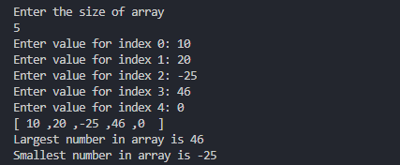

Q)Search given number in array

*#include* <stdio.h>

void storeArr(int *\**arr, int size)

{

*for* (int i *=* 0; i *<* size; i*++*)

    {

        printf("Enter value for index %d: ", i);

        scanf("%d", *&*arr[i]);

    }

}

int searchInArray(int arr[], int size, int num)

{

*for* (int i *=* 0; i *<* size; i*++*)

*if* (arr[i] *==* num)

*return* i;

*return* *-*1;

}

int main()

{

    int n;

    printf("Enter the size of an array:\n");

    scanf("%d", *&*n);

    int arr[n], searchNum;

    storeArr(arr, n);

    printf("\nEnter a number u want to search in array\n");

    scanf("%d", *&*searchNum);

    int res *=* searchInArray(arr, n, searchNum);

    res*==-*1 *?* printf("Number not found in array\n") *:* printf("%d found at index %d",searchNum, res);

*return* 0;

}

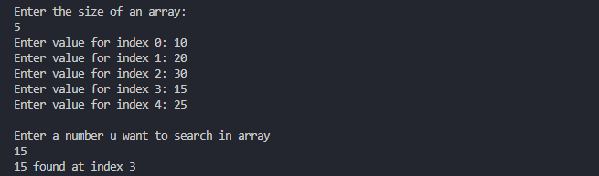

Q3)Find sum of all elements of array using function

*#include*<stdio.h>

int storeNSum(int arr[], int size){

    int sum *=* 0;

*for* (int i *=* 0; i *<* size; i*++*)

    {

        printf("Enter the value at index %d: ", i);

        scanf("%d", *&*arr[i]);

        sum *+=* arr[i];

    }

*return* sum;

}

int main(){

    int n;

    printf("Enter the size of an array:\n");

    scanf("%d", *&*n);

    int arr[n];

    printf("Sum of all elements of array is %d", storeNSum(arr,n));

*return* 0;

}

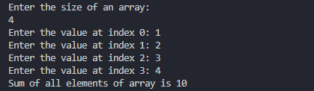

Q4)Print odd and even numbers in array

*#include*<stdio.h>

void storeArr(int *\**arr, int size)

{

*for* (int i *=* 0; i *<* size; i*++*)

    {

        printf("Enter value for index %d: ", i);

        scanf("%d", *&*arr[i]);

    }

}

void printOddEven(int arr[], int size){

    printf("\n--------Even Nums in Array-------\n");

*for* (int  i *=* 0; i *<* size; i*++*)

*!*(arr[i]*%*2) *&&* printf("%d ", arr[i]);

    printf("\n--------Odd Nums in Array-------\n");

*for* (int  i *=* 0; i *<* size; i*++*)

        arr[i]*%*2 *&&* printf("%d ", arr[i]);

}

int main(){

    int n;

    printf("Enter the size of an array:\n");

    scanf("%d", *&*n);

    int arr[n];

    storeArr(arr, n);

    printOddEven(arr, n);

*return* 0;

}

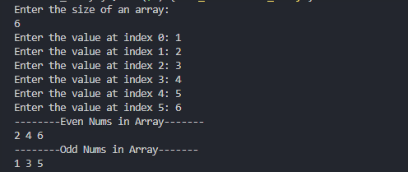

Q5) Print Alternate Numbers in array

*#include*<stdio.h>

void storeArr(int *\**arr, int size)

{

*for* (int i *=* 0; i *<* size; i*++*)

    {

        printf("Enter value for index %d: ", i);

        scanf("%d", *&*arr[i]);

    }

}

void printAlternate(int arr[], int size){

*for* (int i *=* 0; i *<* size; i*=*i*+*2)

    {

        printf("%d ", arr[i]);

    }

}

int main(){

    int n;

    printf("Enter the size of an array:\n");

    scanf("%d", *&*n);

    int arr[n];

    storeArr(arr, n);

    printAlternate(arr, n);

*return* 0;

}

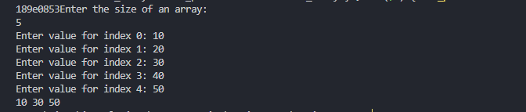

Q6) Print prime nums in array

*#include* <stdio.h>

void checkPrime(int arr[], int size)

{

*for* (int i *=* 0; i *<* size; i*++*)

    {

*if*(arr[i]*==*1) *continue*;

        int isPrime *=* 1;

*for* (int j *=* 2; j *\** j *<=* arr[i]; j*++*)

        {

*if* (arr[i] *%* j *==* 0)

            {

                isPrime *=* 0;

*break*;

            }

        }

        isPrime *&&* printf("%d ", arr[i]);

    }

}

int main()

{

    int n;

    printf("Enter the size of an array:\n");

    scanf("%d", *&*n);

    int arr[n];

*for* (int i *=* 0; i *<* n; i*++*)

    {

        printf("Enter the value at index %d: ", i);

        scanf("%d", *&*arr[i]);

    }

    checkPrime(arr, n);

*return* 0;

}

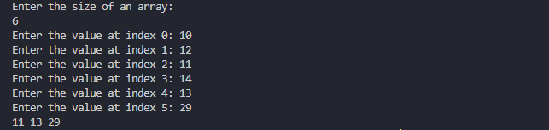

Q7) Take two array and add sum in third array

Ex. Arr[5] = {1,2,3,4,5}

Brr[5] = {10,20,30,40,50}

Crr[5] = {11,22,33,44,55}

*/\**

*7. Take two array and add sum in third array*

*Examplearr[*

*5]= {1,2, 3, 4,5}*

*brr[5]={10,20,30, 40, 50}*

*crr[5]={11,22,33,44,55}*

*\*/*

*#include*<stdio.h>

void storeArr(int arr[], int size){

*for* (int i *=* 0; i *<* size; i*++*)

    {

        printf("Enter the value at index %d: ", i);

        scanf("%d", *&*arr[i]);

    }

}

void findSum(int arr[], int brr[], int size){

    int crr[size];

*for* (int i *=* 0; i *<* size; i*++*)

    {

        crr[i] *=* arr[i]*+* brr[i];

        printf("%d ", crr[i]);

    }

}

int main(){

    int n;

    printf("Enter the size of an array:\n");

    scanf("%d", *&*n);

    int arr[n], sum *=* 0;

*//taking arr 1 from user*

    printf("------Array 1 - arr --------\n");

    storeArr(arr,n);

    int brr[n], crr[n];

*//taking brr (2) from user*

    printf("------Array 2 - brr --------\n");

    storeArr(brr,n);

*//find sum and adding in crr in respective element*

    findSum(arr,brr, n);

*return* 0;

}

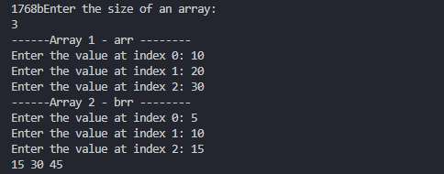

Q8)Merge Two arrays

*#include*<stdio.h>

void storeArr(int arr[], int size){

*for* (int i *=* 0; i *<* size; i*++*)

    {

        printf("Enter the value at index %d: ", i);

        scanf("%d", *&*arr[i]);

    }

}

void displayArr(int arr[], int size){

*for* (int i *=* 0; i *<* size; i*++*)

    {

        printf("%d ", arr[i]);

    }

}

void mergeArr(int arr1[], int size1, int arr2[], int size2, int arr3[]){

*for* (int i *=* 0; i *<* size1*+*size2 ; i*++*)

    {

        arr3[i] *=* i*<*size1 *?* arr1[i] *:* arr2[i*-*size1];

    }

}

int main(){

    int n1;

    printf("Enter the size of an array1:\n");

    scanf("%d", *&*n1);

    int arr1[n1];

*//taking arr 1 from user*

    printf("-----Enter values for Array 1-----\n");

    storeArr(arr1, n1);

    int n2;

    printf("Enter the size of an array1:\n");

    scanf("%d", *&*n2);

    int arr2[n2], n3 *=* n1*+*n2;

*//taking arr 2 from user*

    printf("-----Enter values for Array 2-----\n");

    storeArr(arr2,n2);

    int arr3[n3];

*//adding values from arr1 to arr3*

    mergeArr(arr1, n1, arr2, n2, arr3);

*//printing arr3*

    displayArr(arr3, n3);

*return* 0;

}

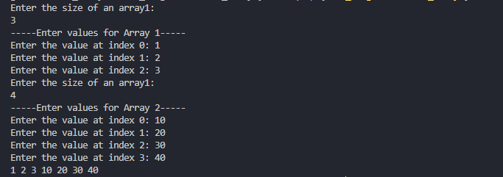

Q)Reverse an array

*#include* <stdio.h>

void displayArr(int arr[], int size)

{

*for* (int i *=* 0; i *<* size; i*++*)

        printf("%d ", arr[i]);

}

void storeArr(int arr[], int size)

{

*for* (int i *=* 0; i *<* size; i*++*)

    {

        printf("Enter the value for index %d: ", i);

        scanf("%d", *&*arr[i]);

    }

}

void reverseArray(int arr[], int n)

{

*for* (int i *=* 0; i *<=* n */* 2; i*++*)

    {

        int temp *=* arr[i]; *// 1 2*

        arr[i] *=* arr[n *-* i *-* 1]; *// a[0] = a[3-0-1] = a[2] = 3 2*

        arr[n *-* i *-* 1] *=* temp; *// a[2] = temp = 1 2*

*// printf("%d ", arr[i]);*

    }

}

int main()

{

    int n;

    printf("Enter the size of an array:\n");

    scanf("%d", *&*n);

    int arr[n];

*// taking arr from user*

    printf("-----Enter values for Array 1-----\n");

    storeArr(arr, n);

*// reverse array*

    reverseArray(arr, n);

*// printing array*

    displayArr(arr, n);

*return* 0;

}

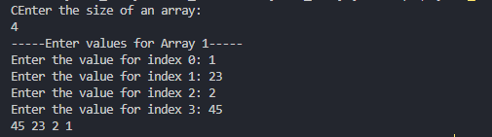

Q)Sort array using function

*#include* <stdio.h>

void displayArr(int arr[], int size)

{

*for* (int i *=* 0; i *<* size; i*++*)

        printf("%d ", arr[i]);

}

void storeArr(int arr[], int size)

{

*for* (int i *=* 0; i *<* size; i*++*)

    {

        printf("Enter the value for index %d: ", i);

        scanf("%d", *&*arr[i]);

    }

}

void sortArray(int arr[], int n)

{

*for* (int i *=* 0; i *<* n; i*++*)

    {

*for* (int j *=* i *+* 1; j *<* n; j*++*)

        {

*if* (arr[i] *>* arr[j])

            {

                int temp *=* arr[i];

                arr[i] *=* arr[j];

                arr[j] *=* temp;

            }

        }

    }

}

int main()

{

    int n;

    printf("Enter the size of an array:\n");

    scanf("%d", *&*n);

    int arr[n];

*// taking arr from user*

    storeArr(arr,n);

*//sort array*

    sortArray(arr, n);

*// printing array*

    displayArr(arr,n);

*return* 0;

}

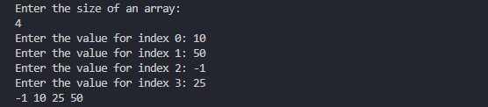

***-----End-----***